WEEK 1: Requirement Analysis and Customer Database Module
- S.KAVIYA (E25AI119)
1.Requirement Analysis
Understanding Art Work Shop Business:
An Art Work Shop system manages the end-to-end process of browsing, purchasing, and managing artworks and art supplies online. It also allows customers to book art workshops. Below is a structured breakdown of the business process, customer data requirements, and entity definitions for system design and database modeling.
The Process Flow
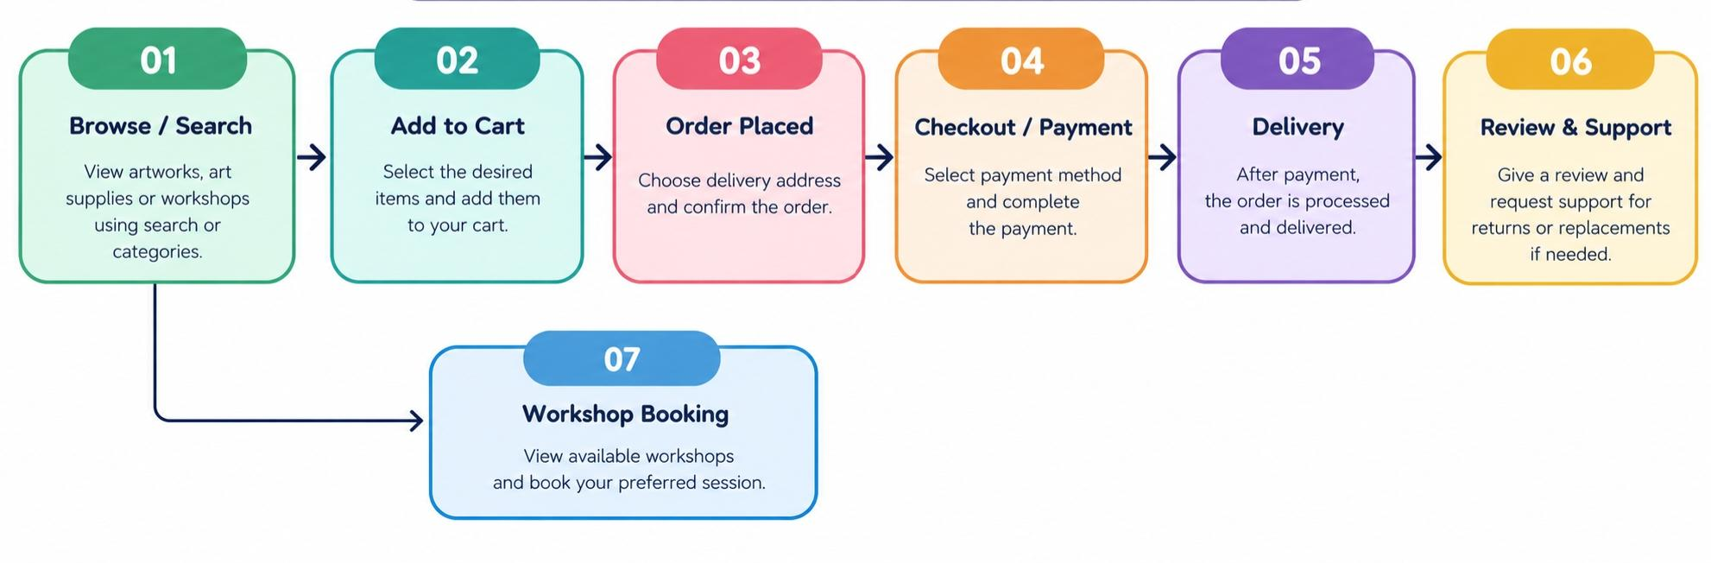
- Browse / Search Artwork: The customer searches for the artwork or art supplies they want to purchase.
- Add to Cart: After selecting the required products, the customer adds them to the cart.
- Order Placed: The customer selects the delivery address and places the order.
- Checkout / Payment: After placing the order, the customer proceeds to checkout and payment.
- Delivery: After payment confirmation, the order is processed and the products are delivered to the customer.
- Review & Support: After successful delivery, the customer can provide a review and request support for returns or replacements, if applicable.
- Workshop Booking: Customers can view available art workshops and book suitable sessions.
Entites:
ENTITY | DESCRIPTION |  | KEY ATTRIBUTES | KEY RELATIONSHIPS
Customer | End -user who purchases artworks and books workshops. |  | Customer_id(PK),customer_name  Phone,email address, password | One- to -many with order,booking
Product | Artwork or art supply listed for sale on the platform. |  | Product_id (PK), seller_id (FK), title, description, price, stock_quantity, category | Many-to-One with Seller, One-to-Many with Review
Workshop | Art classes or sessions available for customers to book. |  | Workshop_id (PK), workshop_name, date, time, duration, fee | One-to-Many with Booking
Booking | Record of a customer’s workshop reservation. |  | Booking_id (PK), customer_id (FK), workshop_id (FK), booking_date, booking_status | Many-to-One with Customer, Many-to-One with Workshop
Order | Transaction representing a customer’s artwork purchase. |  | Order_id (PK), customer_id (FK), artwork_id (FK), order_date, quantity, total_amount, order_status | Many-to-One with Customer, Many-to-One with Artwork, One-to-One with Payment
Payment | Monetary transaction associated with an order. | payment_id (PK), order_id (FK), payment_method, payment_date, amount, payment_status |  | One-to-One with Order
Review | Feedback and rating submitted by a customer for a product. | review_id (PK), customer_id (FK), product_id (FK), rating, comment, created_at |  | Many-to-One with Customer, Many-to-One with Product  Ippo Mam oda format same ah irukku.

Customer table creation:
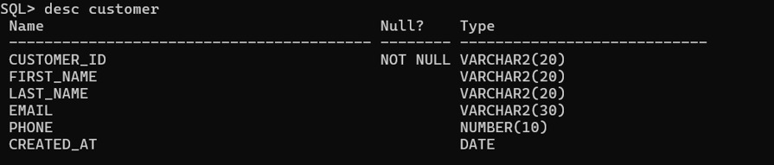

Inserting values:
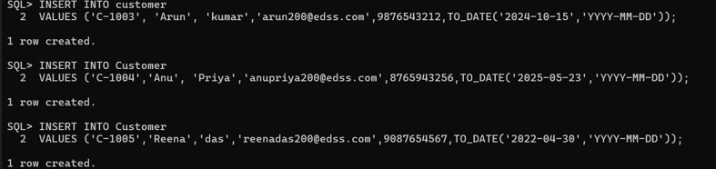
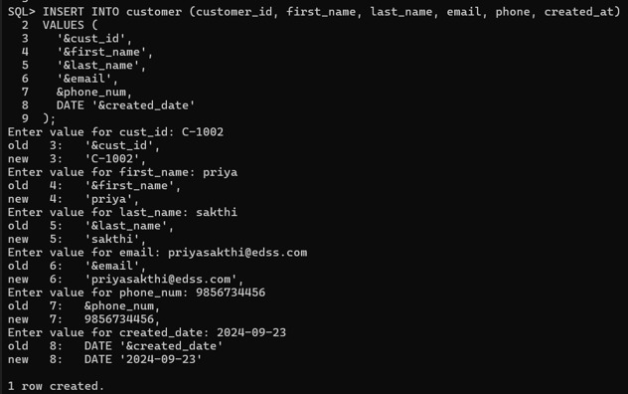

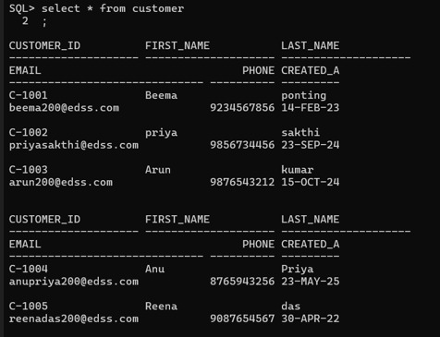
Update:

